**Module: R3: DLD + DSD**

**Section:** Combinational Circuits **Task:** Design Problem

**Design Problem**

**Combination Circuits**

* **Verilog Code:**

//Author: Noman Rafiq

//Date: July 11, 2024

module shifter_circuit (input [7:0] data_in, input [2:0] shift_amount, input shift_direction, output reg [7:0] result);

//Function Definition

function [7:0] shifted_value (input [7:0] data_in, input [2:0] shift_amount, input shift_direction);

begin

if(shift_direction)

shifted_value = (data_in << shift_amount);

else

shifted_value = (data_in >> shift_amount);

end

endfunction

always @(*)

begin

result = shifted_value(data_in, shift_amount, shift_direction);

end

endmodule

* **Testbench:**

module tb_shifter_circuit;

reg [7:0] data_in;

reg [2:0] shift_amount;

reg shift_direction;

wire [7:0] result;

integer results_file;

// Instantiating the shifter_circuit module

shifter_circuit dut (

.data_in(data_in),

.shift_amount(shift_amount),

.shift_direction(shift_direction),

.result(result)

);

initial begin

$dumpfile("wavetrace.vcd");

$dumpvars(0, tb_shifter_circuit);

results_file = $fopen("results.txt", "w");

// Generate 10 random test cases

repeat (10) begin

data_in = $random;

shift_amount = $random;

shift_direction = $random;

#10;

// Self-Checks

if (result == shifted_value(data_in, shift_amount, shift_direction))

$display("Test passed for data_in=%d, shift_amount=%d, shift_direction=%b", data_in, shift_amount, shift_direction);

else

$display("Test failed for data_in=%d, shift_amount=%d, shift_direction=%b", data_in, shift_amount, shift_direction);

$fwrite(results_file, "data_in=%d, shift_amount=%d, shift_direction=%b, result=%d\n", data_in, shift_amount, shift_direction, result);

end

$fclose(results_file);

$finish;

end

function [7:0] shifted_value (input [7:0] data_in, input [2:0] shift_amount, input shift_direction);

begin

if(shift_direction)

shifted_value = (data_in << shift_amount);

else

shifted_value = (data_in >> shift_amount);

end

endfunction

endmodule

* **Output:**

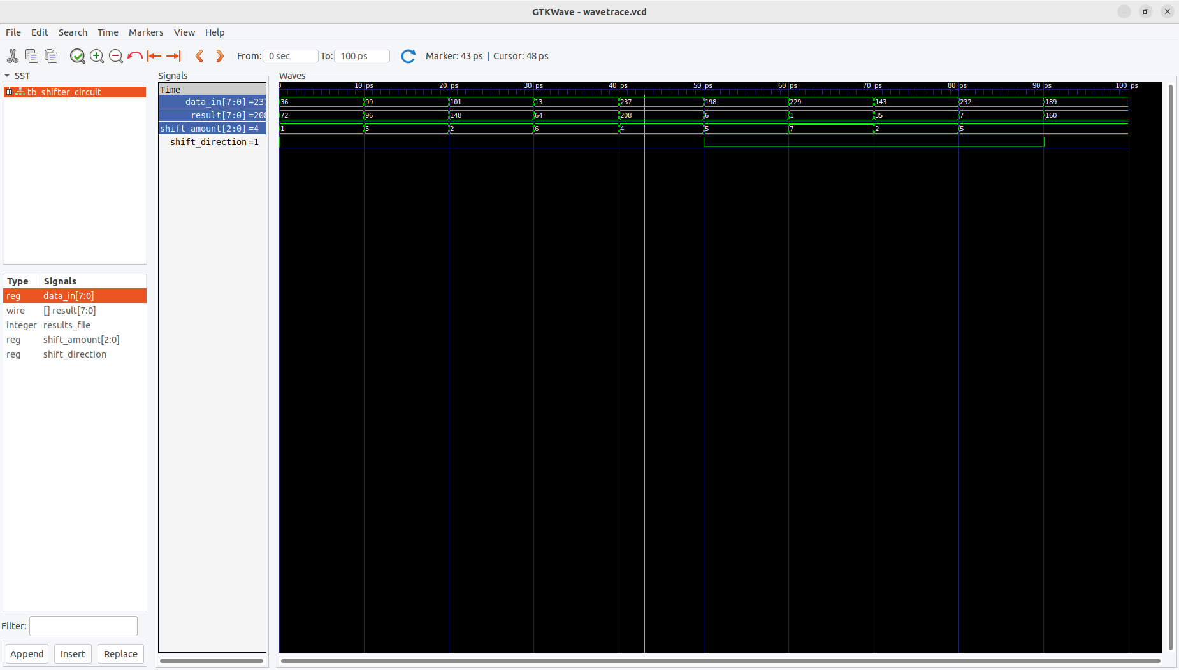

The results have been recorded in **results.txt,** as shown below:

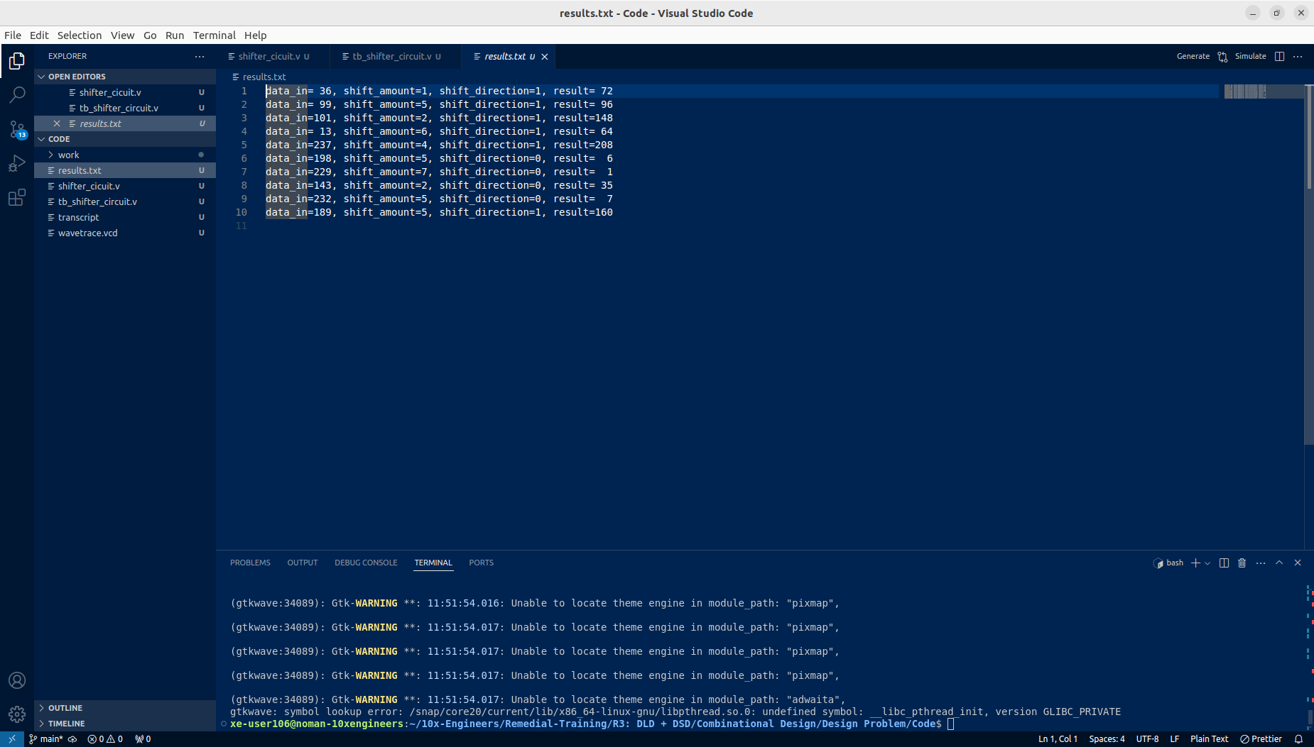

* **Schematics:**

The block-level implementation will be as follows:

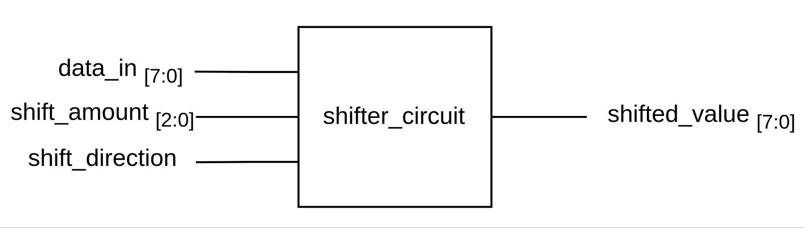

The block will be utilizing left and right shift blocks that take **data_in** and **shift_amount** as inputs and then shifts the value by the n bits provided by the **shift_amount.** The **shift_direction** is used to choose one of the two shift operations. It is achieved through a mux as given below:

